

Dr.(Prof.) Ajay Singh Tomar (Homeopath)
F- 21, Scheme No: 54, Indore, M.P., India, Pin: 452 010
Tel: +91-731-4061911, Cell: +91-9893029893,
Website: www.drtomar.com , email: astomar@drtomar.com
---------------------------------------------------------------------------------------
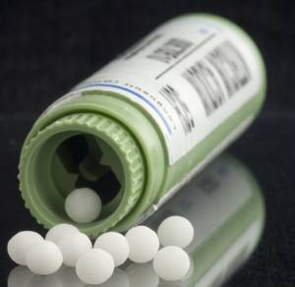

Instructions for Patients

- Homeopathy is safe medicine, which doesn’t have any side-effects.
- It is perfectly safe for all including, infants, small kids, pregnant women, old people etc.
- Medicines are to be kept under the tongue and not to be swallowed, not to be touched by hand, use the bottle cap or a piece of paper.
- Four tablets are to be taken in one dose unless instructed otherwise. If you miss the dose timings, take twice the number of tablets in the next repetition of the same medicine.
- Make sure the mouth is clean before taking the medicines.
- Make a gap of 2 to 5 minutes between light snacks / breakfast / water / milk / Juice / Soup etc. and the medicines. A gap of 30 minutes should be observed with heavy meals like Lunch / Dinner etc.
- Use of Tea / Coffee and strong stimulants is to be avoided during the course of medicines.
- Avoid use of raw Onion / Garlic / Ginger / Asafetida strictly, cooked may be taken casually.
- Smoking and Tobacco in other forms is to be avoided.
- Patients of Hypertension, Diabetes, Cardiac ailments and other ailments which require regular medication can continue their medications along with these medicines, a gap of 20 minutes is recommended.
- During the course of treatment if your local physician recommends some medicines for some other ailments, those medicines can also be continued along with these medicines with a gap of 20 minutes.
- Do not take the regular medicines on the day the morning single dose medicine is taken. You may start the regular medicines from the next day until you reach the next single dose.
- Medicated toothpastes / massage oils / medicated soaps / ointments are to be avoided.
- Diseases develop due to unnatural habits, hence regular exercise, healthy diet and regular physical activity is recommended along with a healthy pattern of thinking. Avoiding stress and anxiety. Living premises should be well ventilated and hygienic.
-------------------------------------------------------------------------------------------------------------------
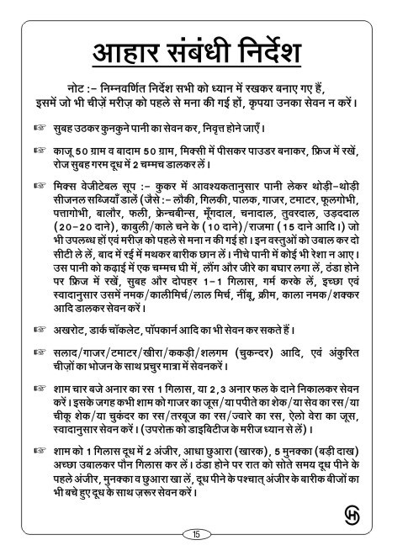
--------------------------------------------------------------------------------------------------------------------

DIET RELATED INSTRUCTIONS

Note: Following directives have been framed keeping everyone in mind. Patients of specific diseases should avoid Items which have been contraindicated for them.

- Take a glass of lukewarm water in the morning before going to the closet.

- Powder 50 grams Almonds and 50 grams Cashews by grinding in mixer. Keep the powder refrigerated. Take 2 teaspoonful’s every morning with a cup of hot milk.

- Mixed vegetable Soup: Take sufficient quantity of water in a pressure cooker and add small quantity of seasonal vegetables ( such as Bottle Gourd, Sponge Gourd / Luffa, Spinach, carrot, tomato, cauliflower, cabbage, Balor, French beans, Green Gram split and skinned (moong dal), bengal gram spilt and skinned (chana dal), Pigeon pea split and skinned, toor dal, urad dal-20 grains of each, Kabuli / black chana-10 grains each, Rajma-15 grains, etc. Whichever are available and have not been advised to the patient. Boil them for 2 whistles; churn them in churner and filter. There should be no fibre in the filtered water. Now season the water thus prepared in a pan with spoonful ghee, clove and cumin seed. Keep it in refrigerator after it cools down. Take one glass in the morning and noon, making it lukewarm. You may add salt/Pepper, lemon, cream, rock-salt/sugar or as per your taste.
- Walnut, dark chocolate, popcorn etc are also recommended.
- Take salad/carrot/tomato/cucumber/beet root etc. And sprouted items in good quantity.
- At 4 O’clock in the afternoon take a glassful of pomegrate juice or seeds of 2, 3 pomegrate. As an alternative on evenings you can take carrot juice/watermelon juice/ papaya shake/ barley juice/ alovera juice depending on your liking. (Diabetic persons should be careful in taking these).
- In the evening boil 2 figs, half date palm and 5 raisin in a glass of milk; till it becomes 3/4th glass. Before going to bed in the night drink the milk. After drinking tiny seeds of fig should also be consumed in remaining milk.

-----------------------------------------------------------------------------------------------------------

Some Translations for your convenience
- English Names - | - Indian / Hindi Names -
Ash Gourd | Petha
Aubergines | Baingan
Banana (raw) | Kela
Beetroot | Chukander
Bitter Gourd | Karela
Bottle Gourd | Lauki
Brinjal | Baingan
Broad Beans | Papdi / Vaal
Cabbage | Pattagobi
Capsicum | Simla Mirch
Carrot | Gajar
Cauliflower | Phoolgobi
Chilli (green) | Harimirch
Chilli (dry red) | Sukhi Lalmirch
Cluster Beans | Gavar
Coconut | Nariyal
Colocasia leaves | Patrel / Patra
Colocasia roots | Arbi
Coriander leaves | Hara Dhania
Corn | Makai
Cucumber | Kheera / Kakdi
Curry leaves | Kadi patta
Dill | Suva bhaji / Soye
Drumstick | Shingh phali
Eggplant | Baingan
French Beans | Fansi
Fenugreek leaves | Methi patta
Garlic | Lahsun
Gherkins | Thendli
Ginger | Adrak
Gooseberry | Amla
Green Bell Pepper | Simla Mirch
Green Mustard | Sarson ka saag
Green Peas | Matar
Green Onion | Hara Pyaz
Jackfruit (raw) | Kathal
Knolkol | Gathgobi
Lady Finger | Bhindi
Lemon | Nimbu
Lettuce leaves | Salad patta
Lotus Stem | Kamal Kakdi
Maize | Bhutta
Mango (raw) | Kaccha Aam / Keri
Mint | Pudina
Mushroom | Khumb / Guchhi
Okra | Bhindi
Onion | Pyaz
Plantain (raw) | Kela
Plantain flower | Kele ka phool
Plantain pith | Kele ka guda
Potato | Aloo / Batata
Pumpkin | Kaddu
Purple Yam | Surti Kand
Radish | Mooli
Ridge Gourd | Tori / Thurai
Snake Gourd | Chichinda / Padval
Spinach | Palak
Sweet Potato | Shakarkand / Ratalu
Tomato | Tamatar
Turnip | Shalgam
Yam | Sooran

-----------------------------------------------------------------------------------------------------------

Some More Translations in different Languages

ENGLISH | HINDI | TAMIL | TELUGU | KANNADA | MARATHIi | KONKANI | Names in Regional Languages
amaranth leaves | chauli, chaulai |  | thotakura | harive soppu | chawli | thambde bhajji, tambdi bhaji  (for red amaranth leaves)
ash gourd, white pumpkin, winter melon | petha | poosanikai | boodida gumadikaya | bood kumbalakai | safed bhopla | kuvale
aubergine, brinjal, eggplant | baingan | kathirikkai | vankaya | badanekayi | vangi | vaingan | begun (bengali), ringan (gujarati), vankaya (telgu)
baby corn
beetroot | chukandar
bottle gourd, opo squash,  white gourd | lauki, ghia | suraikai | sorakaya, aanapakaya | halu  kumbal kai | dudhi | dhave dudhi,  gharduddi | sorakaya (in telugu), (ghia, ghiya in punjabi)
bitter gourd, bitter melon | karela | pavakkai | kakarakaya | hagal kayi | karlya | karathe | kakarakaya (telugu), kalara (oriya), karola (bengali)
cabbage | patta gobhi, paat gobhi | muttai kosu | kosu gadda | ele kosu | kobi |  | band gobi (in punjabi)
carrot | gajar |  | gajaru gadda | gajjari | gajar
capsicum, green bell pepper | shimla mirch | kudai milagai | bunga mirapakay | donne menasinakai | dhobli mirchi, bhopli mirchi | donne mirsang
cauliflower | phool gobi |  | gobi puvvu | hu kosu | flower |  | phulkobi (oriya)
cluster beans | guar ki phali | kothavarangai | goru chikkudu |  | gawar | mitke saang
coconut | nariyal | thengai | kobbari kaya | tengina kai | naral | naarlu
coriander/cilantro leaves | dhania patta | kothamalli thalai | kothimeera | kottambari soppu | kothmir | kothambari pallo
corn | makai, bhutta | makka cholam | mokkajonna | govin jol | makka | jonnalo | challi (in punjabi)
cucumber | kheera | vellarikkai | kaakdi | savte kai | kakdi | tavshen | kaakdi ( in gujarati)
curry leaves | kadi patta | karuveppilai | karivaepaku | karibevu soppu | kadi patta | phanna pallo
dill | suwa, savaa | sataguppi | sadhapa vithulu  /sathapushpa vithulu | sabbasige soppu | shepu | sheppi bhajji | soa (punjabi)
drumsticks | sahjan ki phalli | murungaikkai | mullakkada | nuggekai | shevgyachya  shenga | mashinga sango
fenugreek leaves | methi | vendhayam keerai | menthikura | menthe soppu | methi | methi pallo
french beans, green beans | faras bean, sem |  |  | tingal avre kai | farasbi | tingal avro
garlic | lahsun | poondu | vellulli | bellulli | lasun | losonu
fresh ginger | adrak | inji | allam | shunti | ala | alle | adu (gujarati), allam (telugu), aada (assamese, bengali)
green chilli | hari mirch | pacchai milagai | pachi mirapakaya | HasiMenasu | hirvi mirchi | tarne mirsang
jackfruit | kathal | pala pazham | panasa | halsina hannu | fanas | fanas | fanas (gujarati), chakka pazham (malayalam)
lime, lemon | nimbu | elumichai pazham | nimmakaya | nimbekai | limbu | limbuvo
malabar spinach | poi saag |  | bachhali kura |  | mayalu | valchi bhaji | pui shaak (bengali)
mushroom | kukkurmutta, khumb, guchhi | kaalaan | puttagodugulu | anabi |  | alambo | kaalan
mustard leaves | sarson ka saag | kadugu keerai | aava kura | sasive soppu
onion | pyaaz | vengayam | ullipaya | neerulli | kanda | piyavu,  kando
okra, lady finger | bhindi | vendakkai | bendakaya | bendekai | bhendi | bhend
flat green beans, hyacinth beans | sem ki phali, papdi |  | chikudkaya |  | papdi, val papdi |  | surti papdi or valor papdi (gujarati)
peas | matar, mutter | pattani | pachi batani | batani | hirve vatane | vatano
mint leaves | pudina patta | puthina | pudian | pudina | pudina | marga pallo
pumpkin | kaddu | parangikai | gummadikaya | kumbalkai  (sarekai) | bhopla
potato | aloo | urulaikilangu | bangaladumpa | batate | batata | batato | alu
radish, daikon | mooli | mullangi | mullangi | moolangi | mula | moolangi
radish pods | moongra, mogri |  |  |  |  |  | moongre (in punjabi)
raw plaintain,  unripe raw banana | kacha kela | balekai,  valaikkai | aratikaya | balekai | kachche kele | harve kele
red chili | lal mirch | vara milagai | pandu mirapakaya | kempu menasinakai | lal mirchi | thambde (red) mirsang
snake gourd | parora  (chichinda) |  | potlakay | paddul kai | padwal | paddul
spinach | palak | pasala keerai | palakura | palak, basale | palak | palak, vali
sweet potato | shakarkandi | sakaravalli kilangu | chilakadadumpa | genasu | ratale | kanang | ratalu
tomato | tamatar | thakkali | rama mulaga kaya | kembhoota
taro roots or colocasia | arbi | seppenkilangu | chamadumpa |  | alu
ivy gourd or gherkins | tindora |  | dondakaya | tondekai | tendli | tendle | kundru (oriya)
turnip | shalgam, shalzam | nookol | knool khol | navalkhol | salgam | kon
elephant yam | sooran, suran, jimikand | senai kizhangu | kanda | suvarna gedde,  panjar gadde | suran | surnu
potato | aloo, alu | urulaikishangu,  urulaikizhalungu | bangaaladumpa |  | batata | batato | batata or bateta in gujarati

Thanks.
--------------------------------------------------------------------------------------------------------------------

